**LEVEL 1, WEEK 3**

**STUDENT PACKET**

**ACTIVITY ONE:**

CLOTHING

Answer the questions about what clothes people are wearing.

Contestar las preguntas sobre qué ropa llevan la gente.

Maria Jorge Emily Jason Ana Mark

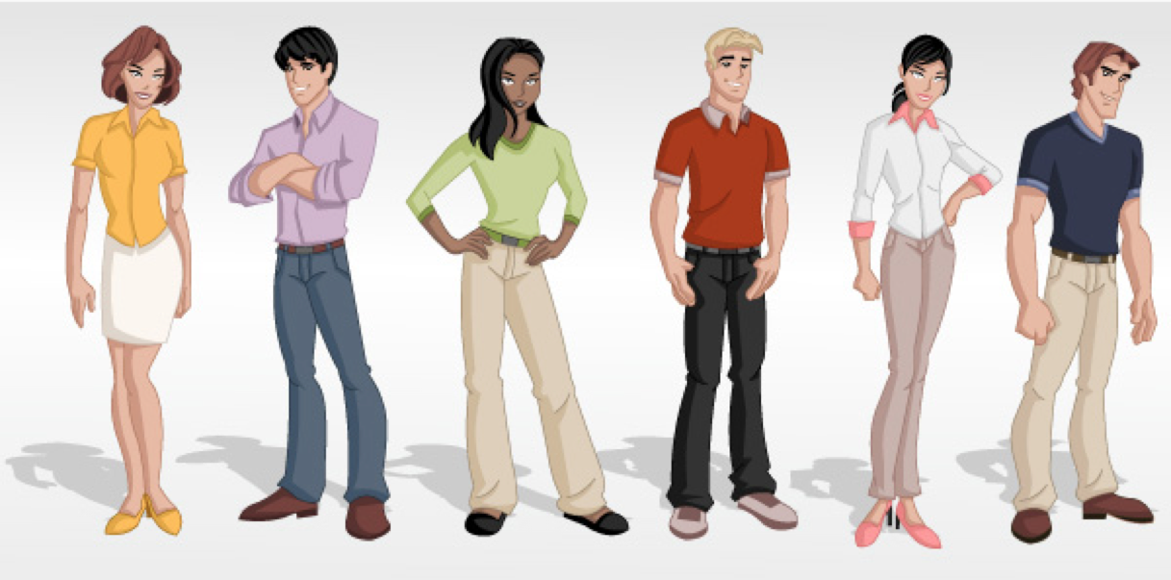

Who is wearing the green shirt? Who is wearing the blue pants?

______________________________________ ______________________________________

What color are Maria’s shoes? Is Ana wearing socks?

______________________________________ ______________________________________

Who does not wear pants? What color is Jason’s shirt?

______________________________________ ______________________________________

Which people have black hair?

____________________________________________________________________________

**ACTIVITY TWO:**

BODY PARTS

Label each body part with its name in English.

Marcar cada parte del cuerpo con su nombre en inglés.

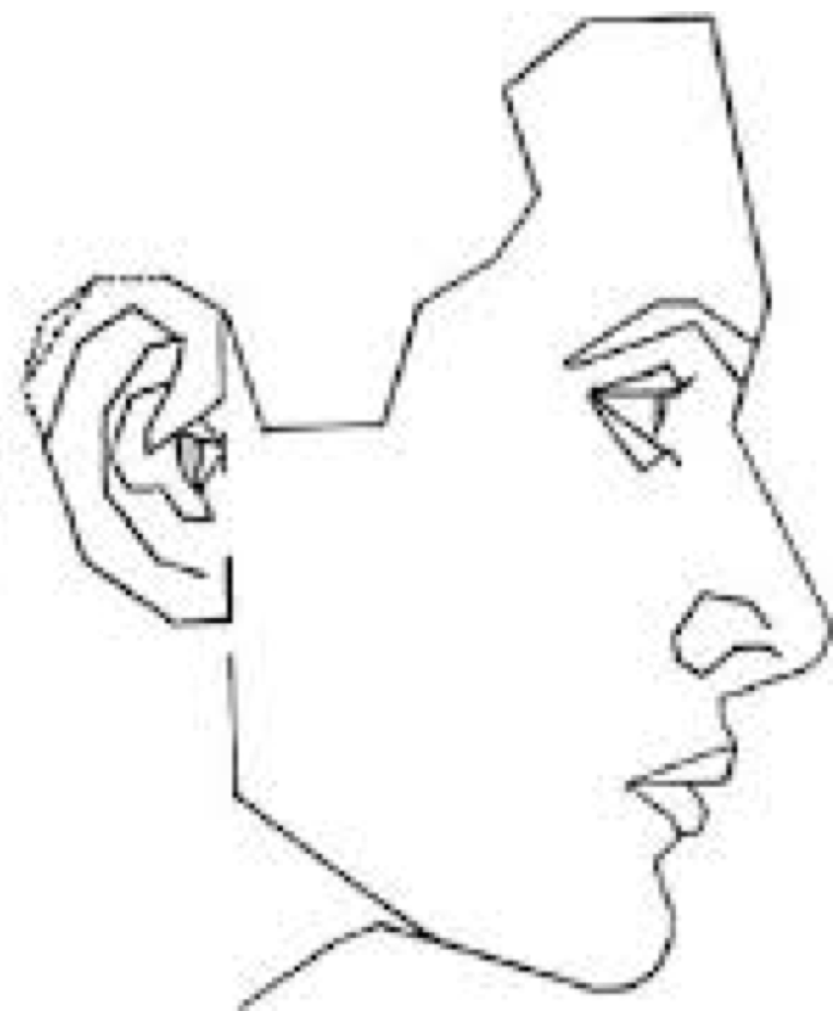

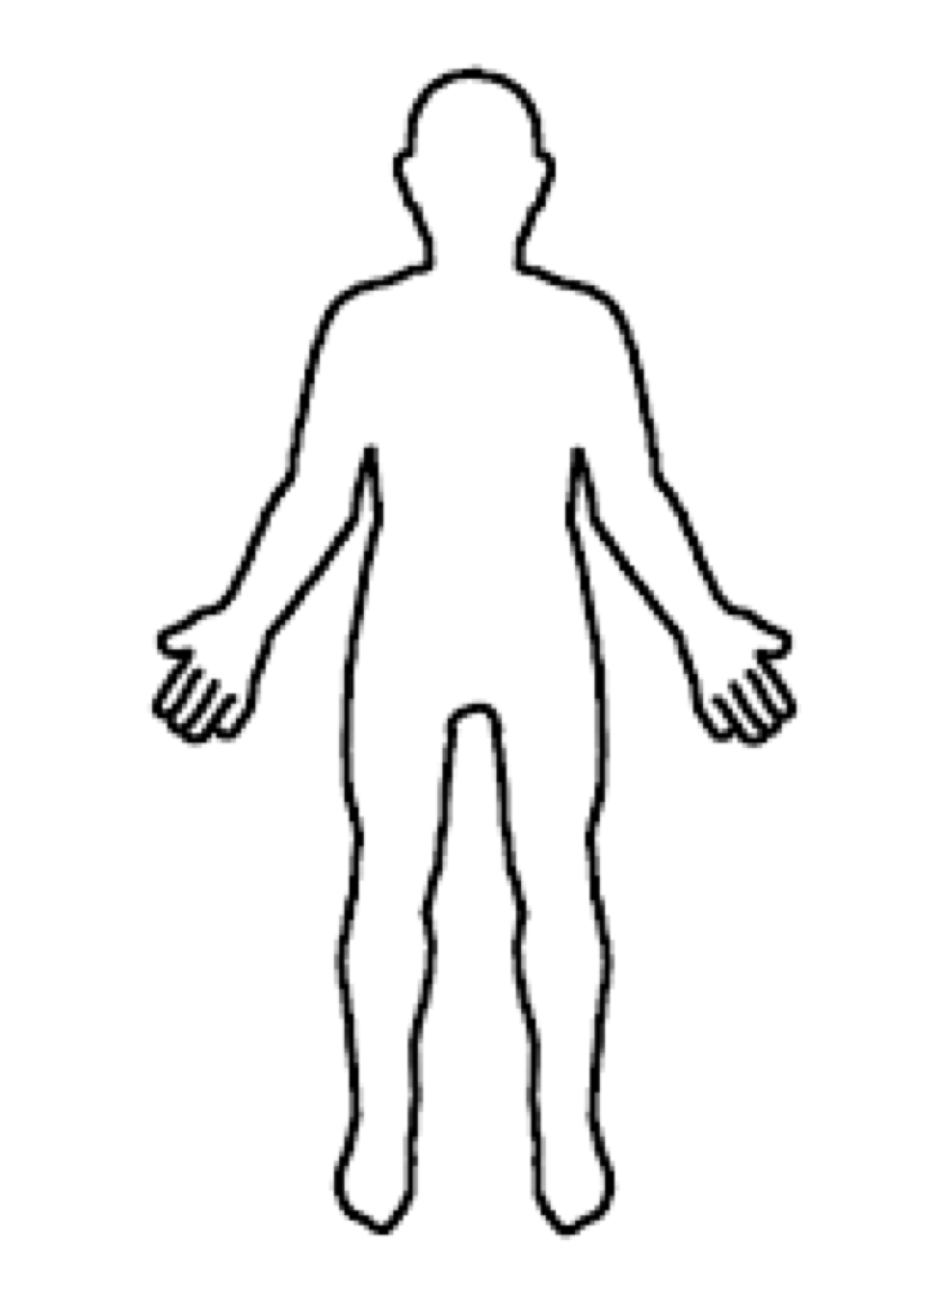

**ACTIVITY THREE:**

BEST AND WORST

Ganar $1,000,000

Ir de vacaciones con tu familia en un lugar bello

Hacer algo divertido con tus amigos

Tener un día ordinario

Perder tus llaves

Tener un resfriado

Oír noticia muy mala

Which of these are good? ¡Puede ser más que uno!

_________________________________________________________________________________________________________

Which of these are great? ¡Puede ser más que uno!

_________________________________________________________________________________________________________

Which of these is the best?

_________________________________________________________________________________________________________

Which of these is bad? ¡Puede ser más que uno!

_________________________________________________________________________________________________________

Which of these is awful? ¡Puede ser más que uno!

_________________________________________________________________________________________________________

Which of these is the worst?

_________________________________________________________________________________________________________

Which is better, “Ir de vacaciones con tu familia en un lugar bello” or “Perder tus llaves”?

_________________________________________________________________________________________________________

Which is worse, “Ganar $1,000,000” or “Tener un día ordinario”?

_________________________________________________________________________________________________________

Which is your favorite?

_________________________________________________________________________________________________________

**ACTIVITY FOUR:**

OTHER SUPERLATIVES

Following the example, make sentences that compare the things.

Según el ejemplo, hacer frases que comparan las cosas.

Ejemplo:

Ben, Rosa, Reynaldo (happy) = Ben is happier than Rosa, but Reynaldo is the happiest.

Television, hamburger, car (big)

_________________________________________________________________________________________________________

They, she, you (funny)

_________________________________________________________________________________________________________

Bread, pasta, milk (white)

_________________________________________________________________________________________________________

My son, my daughter, his friend (quiet)

_________________________________________________________________________________________________________

Go to the store, go to work, relax (good)

_________________________________________________________________________________________________________

Her house, his house, Elena’s house (small)

_________________________________________________________________________________________________________

**ACTIVITY FIVE:**

DATES AND TIMES

Answer these questions in English.

Contestar estas preguntas en inglés.

¿Qué día es tu cumpleaños?

________________________________________________________________________________________________________

What is the best day of the week?

________________________________________________________________________________________________________

¿A qué hora despiertas?

________________________________________________________________________________________________________

¿En qué parte del día despiertas?

________________________________________________________________________________________________________

¿A qué hora comes la cena?

________________________________________________________________________________________________________

¿En qué parte del día comes el almuerzo?

________________________________________________________________________________________________________

Which days do you go to work?

________________________________________________________________________________________________________

¿Cuáles son los meses fríos en Boston?

________________________________________________________________________________________________________

¿Qué día es hoy? Escribir la día de la semana y la fecha.

________________________________________________________________________________________________________

¿Qué será la fecha en una semana?

________________________________________________________________________________________________________

Which month is your favorite?

________________________________________________________________________________________________________